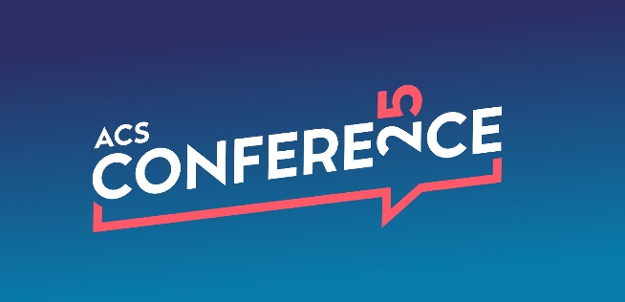

Tuesday 8th April 2025
The Vox, Resorts World, Birmingham

Session 1: Listen …

0930 Introduction - James Lowman
Short film from Howard Stoeckel, WaWa
Keynote speaker Greg Williams
Films with
- Chris Gheysens, WaWa
- Tim Josephs, One Stop
- Katie Secretan, Nisa
Panel
Greg Williams, Tim Josephs, Katie Secretan
1055 Brunch break

Session 2: … Act!
1140 Welcome back – James Lowman
Ideas battle – Sarah C Johnson
- Rav Garcha, Atul Sodha, Sophie Williams, Amrit Singh
- Fiona Malone, Natalie Lightfoot, Bobby Singh, Joshua James
Films with
- Julian Smith Unitas
- Simon Eastwood, Southern Co-op
- Simply Fresh at Gridserve
- Dan Quest, BonVeno
Panel
- Debbie Robinson, Central Co-op
- Nathalie Fullerton, One Stop
- James Badger, Morrisons
30th Anniversary
- Debbie Robinson
- Jonathan James
- Ramesh Shingadia
1310 Lunch

